Sal f
Golden Valley High School
Wm. S. Hart Union High School District
“Home of the Grizzlies”
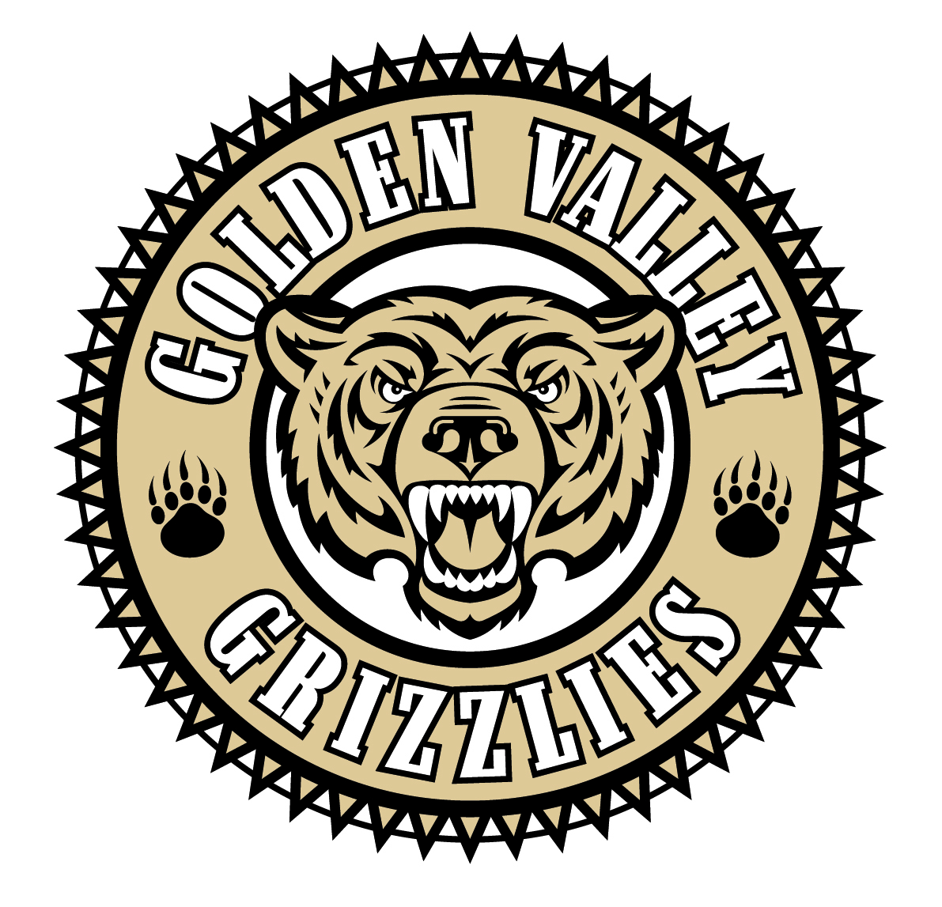
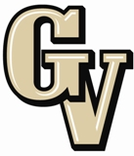

Parent Advisory Council (PAC) Meeting
March 24, 2014
6:30 PM

AGENDA

- PAC Meeting Welcome Sal Frias

- Secretary’s Report ACTION Jennifer Ryan

- Treasurer’s Report ACTION Emily Curtis

- President’s Report Sue Alterman

- District Advisory Council (DAC) Report Monica Camacho

- Parent Communications Council (PCC) Report Cherise Moore

- New Hart District Chief Financial Officer Erin Lillibridge

- Local Control Funding Update Erin Lillibridge

- WASC Visit Review Sal Frias

Announcements: 4/2 - 4/4 GVHS Performing Arts Presents “The Wiz” 7 – 9 pm
4/3 Providence Blood Drive 8:30 am – 2 pm (ROTC)
4/7 – 4/11 Spring Break
4/16 National Honor Society Spring Induction 7 pm
4/20 Easter Sunday
4/22 & 4/24 8th Grade Tours of GV 5:30 pm - 6:30 pm
4/25 Faculty Follies 7 pm
4/29 8th Grade Tours of GV for Special Populations 5:30 – 6:30 pm

Next Meeting: May 5, 2014

The mission of GVHS is to provide a quality education to a diverse student population, develop each student’s maximum potential, and prepare students for success in the global community.

